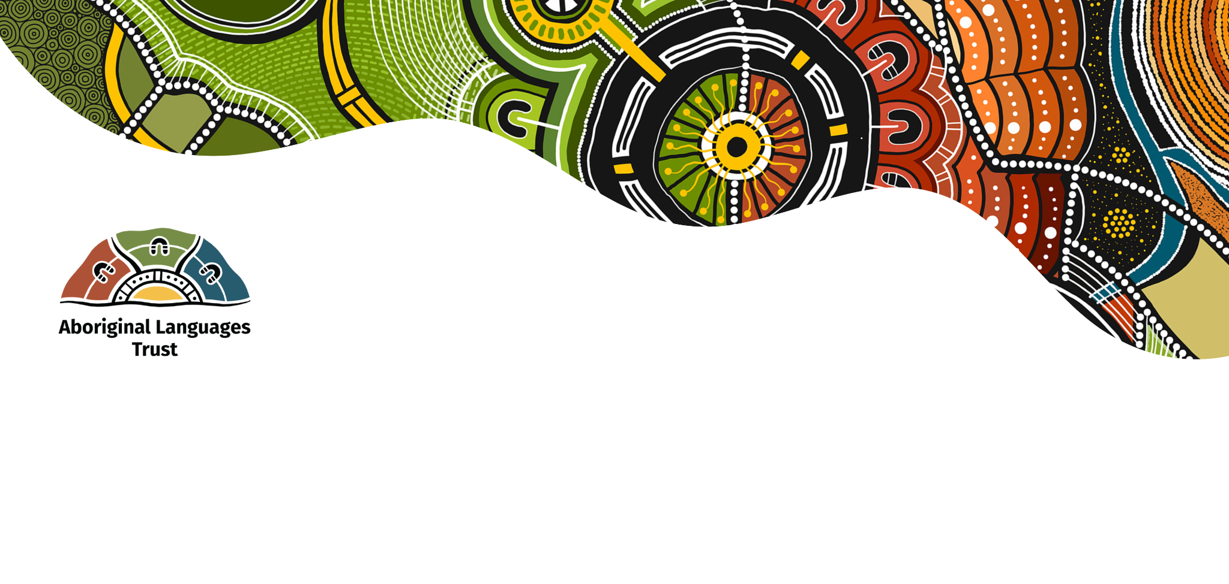
Access to Country for Language Teaching and Learning
Case study image carousels: Accessible format

Carousel 1: Language on Country programs are enabled by strong relationships.

Image | Text and image Alt text
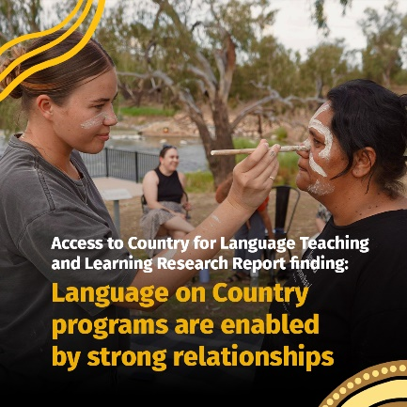 | Access to Country for Language Teaching and Learning Research Report finding: Language on Country programs are enabled by strong relationships  Image: Photo of Maddy painting ochre on Lacey’s face, outside in the bush among gumtrees, another woman pictured in the background.
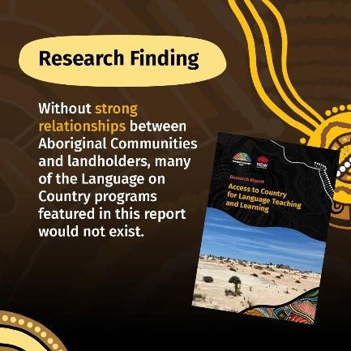 |  | Research finding: Without strong relationships between Aboriginal Communities and landholders, many of the Language on Country programs featured in this report would not exist.  Image: Front cover of the Access To Country for Language Teaching and Learning Report.
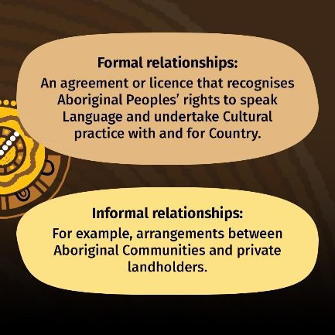 |  | Formal relationships: An agreement or licence that recognises Aboriginal Peoples’ rights to speak Language and undertake Cultural practice with and for Country.  Informal relationships: For example, arrangements between Aboriginal Communities and private landholders.
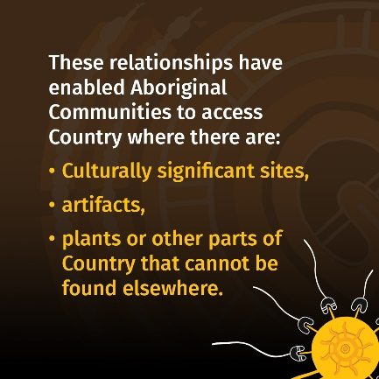 |  | These relationships have enabled Aboriginal Communities to access Country where there are: Culturally significant sites, artifacts, plants or other parts of Country that cannot be found elsewhere.
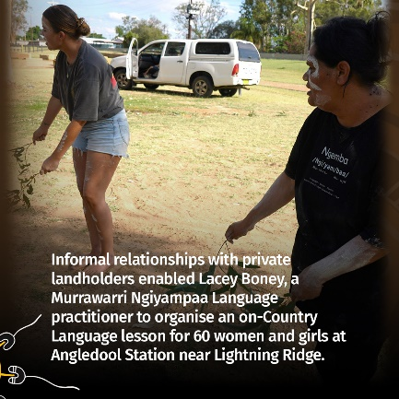 |  | Informal relationships with private landholders enabled Lacey Boney, a Murrawarri Ngiyampaa Language practitioner to organise an on-Country Language lesson for 60 women and girls at Angledool Station near Lightning Ridge.  Image: Photo of Lacey and Maddy dancing holding eucalyptus leaves.
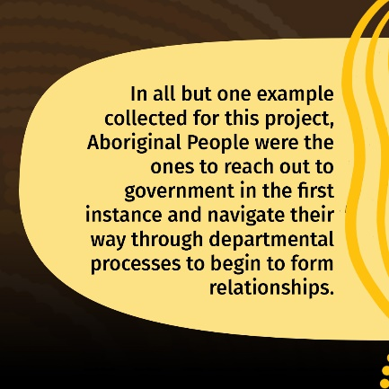 |  | In all but one example collected for this project, Aboriginal People were the ones to reach out to government in the first instance and navigate their way through departmental processes to begin to form relationships.
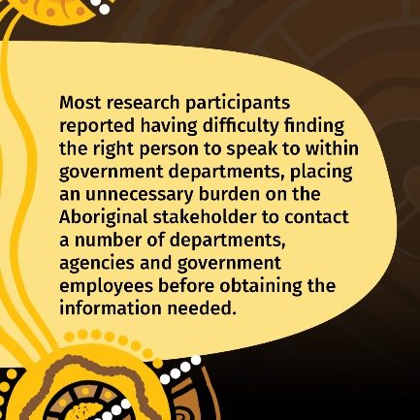 |  | Most research participants reported having difficulty finding the right person to speak to within government departments, placing an unnecessary burden on the Aboriginal stakeholder to contact a number of departments, agencies and government employees before obtaining the information needed.
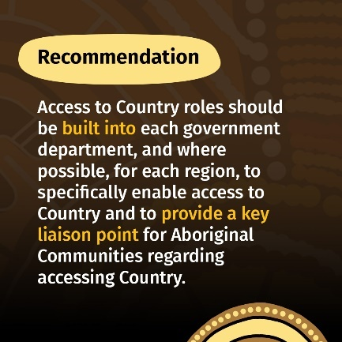 |  | Recommendation: Access to Country roles should be built into each government department, and where possible, for each region, to specifically enable access to Country and to provide a key liaison point for Aboriginal Communities regarding accessing Country.
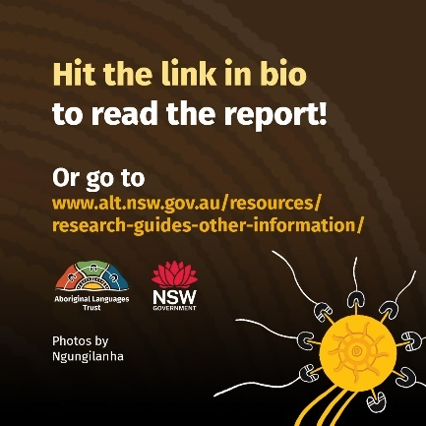 |  | Hit the link in bio to read the report! Or go to www.alt.nsw.gov.au/resources/research-guides-other-information/  Photos by Ngungilanha  Image: NSW Aboriginal Languages Trust logo and NSW Government logo

Carousel 2: Teaching Language on Country has benefits for teachers, students, Country and Language

Image | Text and image Alt text
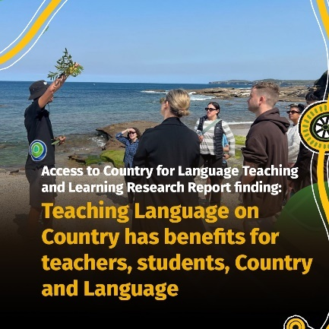 | Access to Country for Language Teaching and Learning Research Report finding: Teaching Language on Country has benefits for teachers, students, Country and Language  Image: Male teacher leading lesson holds eucalypus leaves in the air as people watch, standing on beach at La Perouse.
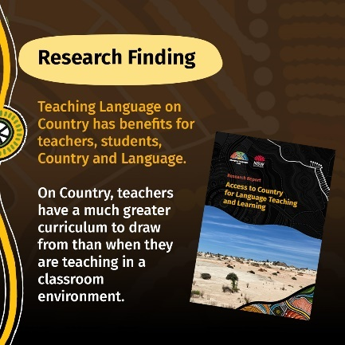 |  | Research finding: Teaching Language on Country has benefits for teachers, students, Country and Language.  On Country, teachers have a much greater curriculum to draw from than when they are teaching in a classroom environment.  Image: Front cover of the Access To Country for Language Teaching and Learning Report.
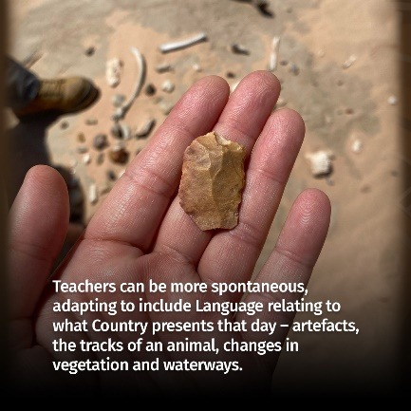 |  | Teachers can be more spontaneous, adapting to include Language relating to what Country presents that day – artefacts, the tracks of an animal, changes in vegetation and waterways.  Image: Hand holding stone artefact at Lake Mungo.
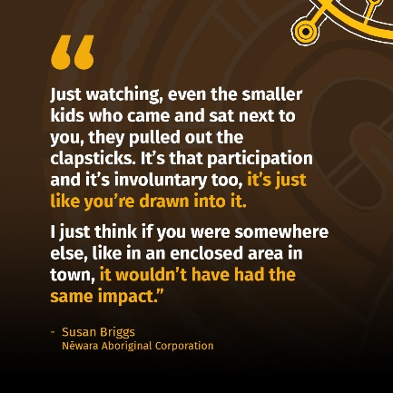 |  | “Just watching, even the smaller kids who came and sat next to you, they pulled out the clapsticks. It’s that participation and it’s involuntary too, it’s just like you’re drawn into it.  I just think if you were somewhere else, like I just think if you were somewhere else, like in an enclosed area in town, it wouldn’t have had the same impact.”  - Susan Briggs  Nēwara Aboriginal Corporation
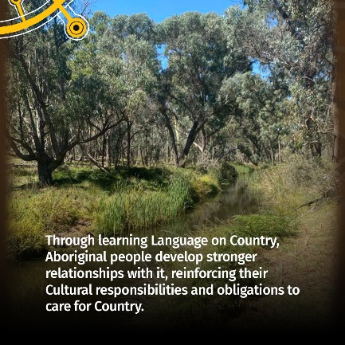 |  | Through learning Language on Country, Aboriginal people develop stronger relationships with it, reinforcing their Cultural responsibilities and obligations to care for Country.  Image: Photo healthy creek, grasses and trees at Nyambinga Kyuna bush block.
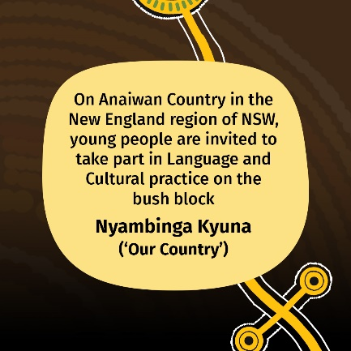 |  | On Anaiwan Country in the New England region of NSW, young people are invited to take part in Language and Cultural practice on the bush block Nyambinga Kyuna (‘Our Country’)
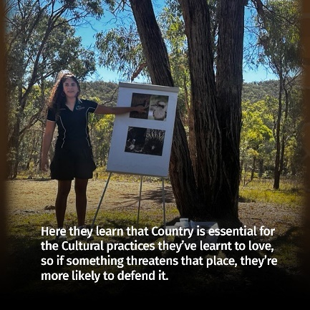 |  | Here they learn that Country is essential for the Cultural practices they’ve learnt to love, so if something threatens that place, they’re more likely to defend it.  Image: Photo of young woman teaching lesson in the bush in front of a tree, pointing to printed images of a kookaburra and echidna on a presentation stand.
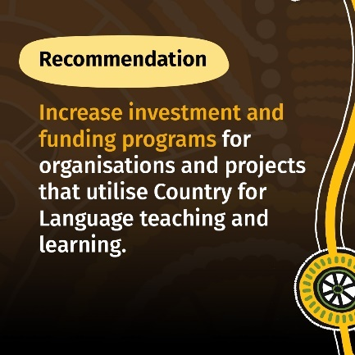 |  | Recommendation: Increase investment and funding programs for organisations and projects that utilise Country for Language teaching and learning.
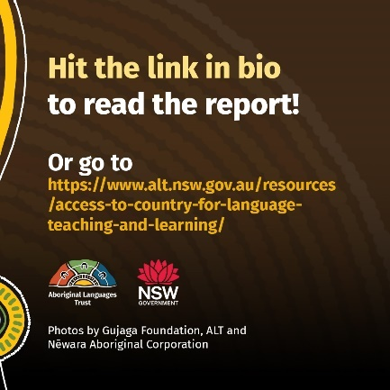 |  | Hit the link in bio to read the report! Or go to https://www.alt.nsw.gov.au/resources/access-to-country-for-language-teaching-and-learning/  Photos by Gujaga Foundation, ALT and Nēwara Aboriginal Corporation  Image: NSW Aboriginal Languages Trust logo and NSW Government logo

Carousel 3: Restrictions around Cultural practices can inhibit Language learning

Image | Text and image Alt text
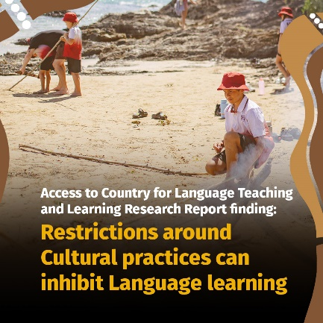 | Access to Country for Language Teaching and Learning Research Report finding: Restrictions around Cultural practices can inhibit Language learning  Image: Child in Giingana Gumbaynggirr Freedom School unform bends down near campfire on Diggers beach on a sunny day.
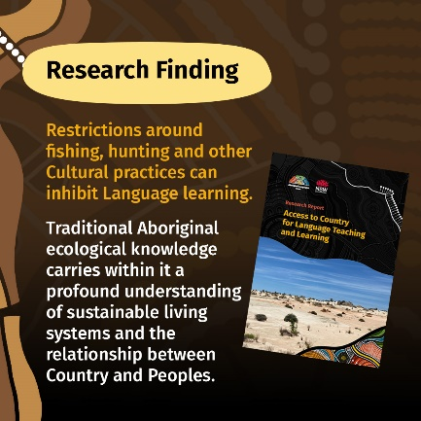 |  | Research finding: Restrictions around fishing, hunting and other Cultural practices can inhibit Language learning.  Traditional Aboriginal ecological knowledge carries within it a profound understanding of sustainable living systems and the relationship between Country and Peoples.  Image: Front cover of the Access To Country for Language Teaching and Learning Report.
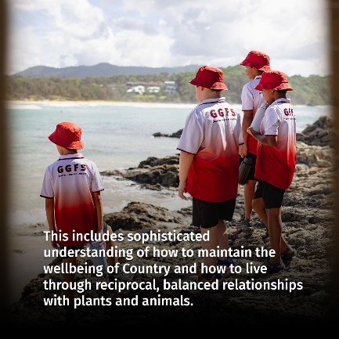 |  | This includes sophisticated understanding of how to maintain the wellbeing of Country and how to live through reciprocal, balanced relationships with plants and animals. Image: Children in Giingana Gumbaynggirr Freedom School unform look out to sea from Diggers beach on a sunny day.
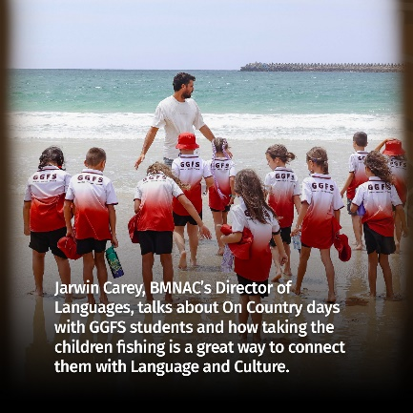 |  | Jarwin Carey, BMNAC’s Director of Languages, talks about On Country days with GGFS students and how taking the children fishing is a great way to connect them with Language and Culture.  Image: Children in Giingana Gumbaynggirr Freedom School unform stand on Diggers beach on a sunny day with teacher Jarwin Carey.
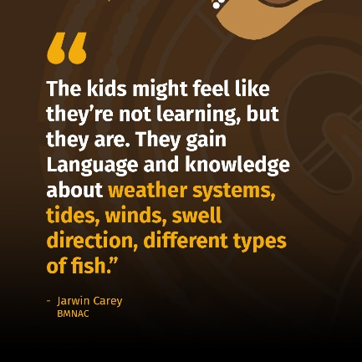 |  | “The kids might feel like they’re not learning, but they are. They gain Language and knowledge about weather systems, tides, winds, swell direction, different types of fish.”  - Jarwin Carey  BMNAC
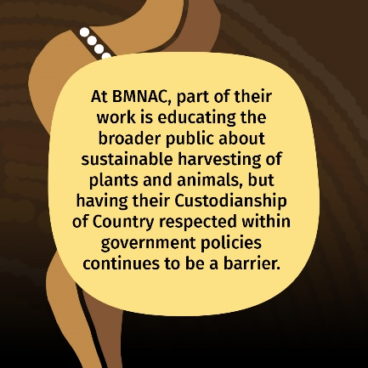 |  | At BMNAC, part of their work is educating the broader public about sustainable harvesting of plants and animals, but having their Custodianship of Country respected within government policies continues to be a barrier.
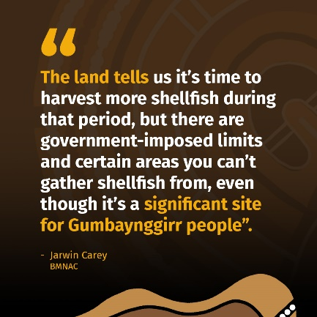 |  | “The land tells us it’s time to harvest more shellfish during that period, but there are government-imposed limits and certain areas you can’t gather shellfish from, even though it’s a significant site for Gumbaynggirr people”.  - Jarwin Carey  BMNAC
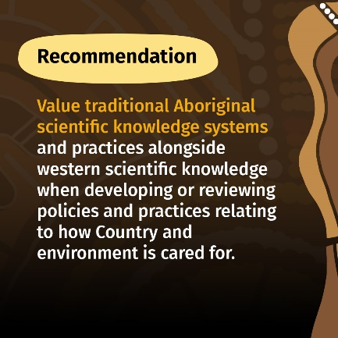 |  | Recommendation: Value traditional Aboriginal scientific knowledge systems and practices alongside western scientific knowledge when developing or reviewing policies and practices relating to how Country and environment is cared for.
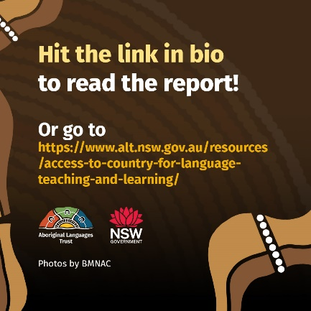 |  | Hit the link in bio to read the report! Or go to https://www.alt.nsw.gov.au/resources/access-to-country-for-language-teaching-and-learning/  Photos by BMNAC  Image: NSW Aboriginal Languages Trust logo and NSW Government logo

